COURSE NAME: Theory of Computation COURSE CODE: CSA1304

COURSE OUTCOME COVERED

CO2: Design Finite Automata DFA, NFA, ε-NFA and demonstrate their equivalence for recognizing regular languages. (BL:3)

Assessment Tool Weightage: 10%

QUESTIONS: 5 Total Marks:25
Duration : 1 Hour

Application Based Question

Code of Conduct:

I SRIVARSHA M-192371010 (Name / Reg No) certify that this submission is my original work and that I have
adhered to the guidelines specified for this assessment.
I understand that any violation of academic integrity rules will result in disciplinary action. Signature of the student:
SRIVARSHA M
- In modern digital systems such as embedded security devices, ATM machines, and authentication modules, password validation must be efficient and reliable. Design a Deterministic Finite Automaton (DFA) over the alphabet Σ = {0,1} to validate passwords that end with the pattern "01".Further, minimize the DFA and analyze how the optimized design improves system efficiency in real-world hardware implementations

- In web applications, validating user input is essential to ensure correctness, security, and performance. Design a regular expression to validate a specific input pattern "aaaabb" over the alphabet Σ = {a, b}.Further, analyze how regular languages and regular expressions are used to efficiently validate user inputs in real-world web applications.

- In modern computing systems such as intrusion detection systems, compilers, and real-time monitoring tools, pattern recognition plays a critical role. Demonstrate how the regular expression a*b* can be converted into an equivalent finite automaton (FA).Further, explain why regular expressions and finite automata are equivalent models and how they are effectively used in real-time detection systems.
- In compiler design, not all patterns can be recognized using finite automata. Using the pumping lemma, demonstrate why the language L= { aⁿbⁿ | n ≥ 0 } cannot be recognized by any finite automaton. Further, analyze the implications of this limitation in the design of modern compilers.
- Modern systems such as intrusion detection, spam filtering, and input validation often require combining multiple pattern-matching rules. Explain how the closure properties of regular languages enable the combination of multiple detection rules. Further, justify why the resulting language after applying these operations remains regular, ensuring efficient implementation using finite automata

Question 1 — Password Validation using DFA
In modern digital systems such as embedded security devices, ATM machines, and authentication modules, password validation must be efficient and reliable. We design a Deterministic Finite Automaton (DFA) over Σ = {0, 1} that accepts exactly those strings which end with the pattern "01", then minimize it and analyze the real-world impact.

1.1 Problem Definition
Language to be recognized: L = { w ∈ {0,1}* | w ends with the substring "01" }. A string belongs to L only if the last two symbols read are 0 followed by 1 (e.g., 01, 001, 1101, 100101 ∈ L, while 10, 111, 00, ε ∉ L).

1.2 Initial DFA Construction
We first construct a DFA by directly tracking recent history of the input. This gives a straightforward, but not yet optimal, 4-state machine:
A = start state (no useful suffix seen) B = last symbol read was 0 C = last two symbols read were '01' → ACCEPTING D = reached C, then read another 0
State | On input 0 | On input 1 | Accepting?
A (start) | B | A | No
B | B | C | No
C | D | A | Yes
D | D | C | No
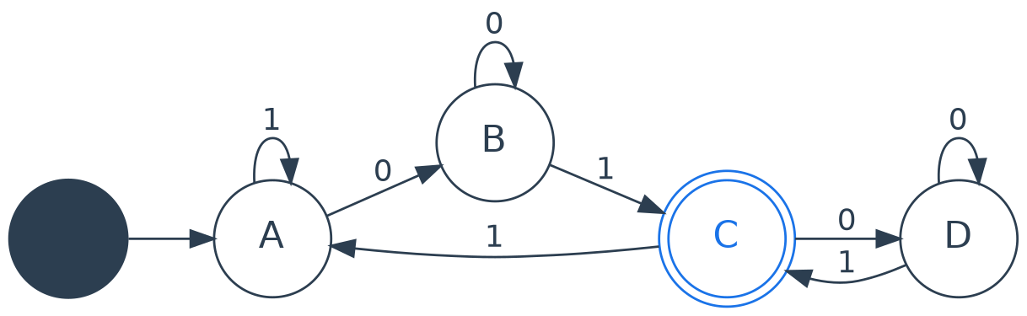
Fig. 1.1 — Initial (unminimized) 4-state DFA for strings ending in "01"

1.3 Minimization (Partition Refinement)
We apply the table-filling / equivalence-partition method to check whether any two states behave identically:
- Partition 0: split states into Accepting = {C} and Non-Accepting = {A, B, D}.
- Check transitions of A, B, D on symbol 0: A→B, B→B, D→D — B and D both land in the Non-Accepting group, while A also lands there; check symbol 1 next.
- Check transitions on symbol 1: A→A (non-accepting group), B→C (accepting group), D→C (accepting group). B and D behave identically on both symbols (0→same group, 1→C), so B ≡ D. A differs from both (A→A on 1, not C), so A stays separate.
- Merge B and D into a single state B. No further splits are possible — the automaton is now minimal with 3 states: {A, B, C}.
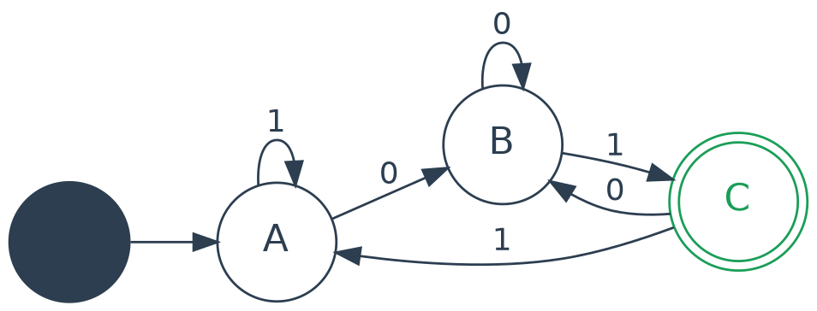
Fig. 1.2 — Minimized DFA (3 states) for strings ending in "01"

1.4 Formal Minimal DFA
M = (Q, Σ, δ, q0, F) where Q = {A, B, C}, Σ = {0,1}, q0 = A, F = {C}, and:
δ(A,0)=B δ(A,1)=A δ(B,0)=B δ(B,1)=C δ(C,0)=B δ(C,1)=A
Trace for input "1001": A --1--> A --0--> B --0--> B --1--> C. Since C is accepting and the string genuinely ends in "01", the DFA correctly accepts.

1.5 Real-World Efficiency Impact
- Fewer states (4 → 3) mean fewer flip-flops / registers are needed to encode the current state in hardware (embedded security chips, ATM firmware), directly reducing silicon area and power draw.
- Fewer transitions reduce the size of the lookup table used by the state machine, so each input bit is processed in fewer clock cycles — critical for real-time authentication modules that must respond within strict latency budgets.
- A minimal DFA has no redundant or unreachable states, eliminating wasted comparisons and lowering the chance of implementation bugs in safety-critical validation logic.
- Because the DFA is deterministic, exactly one transition exists per symbol, guaranteeing predictable, tamper-resistant execution — an important property for security modules.

Question 2 — Regular Expression for Web Input Validation
In web applications, validating user input is essential for correctness, security, and performance. We design a regular expression that validates the exact fixed input pattern "aaaabb" over Σ = {a, b}.

2.1 Regular Expression
Regex: aaaabb
This is a literal (concatenation-only) regular expression: r = a · a · a · a · b · b. It matches one and only one string — the exact sequence "aaaabb" — and rejects every other string over {a, b}, since a fixed literal pattern has no alternation (|) or repetition (*, +) operators.

2.2 Equivalent Finite Automaton
Because every regular expression has an equivalent finite automaton (Kleene's Theorem), the literal pattern corresponds to a simple 6-state accepting chain plus a trap state for any deviation:
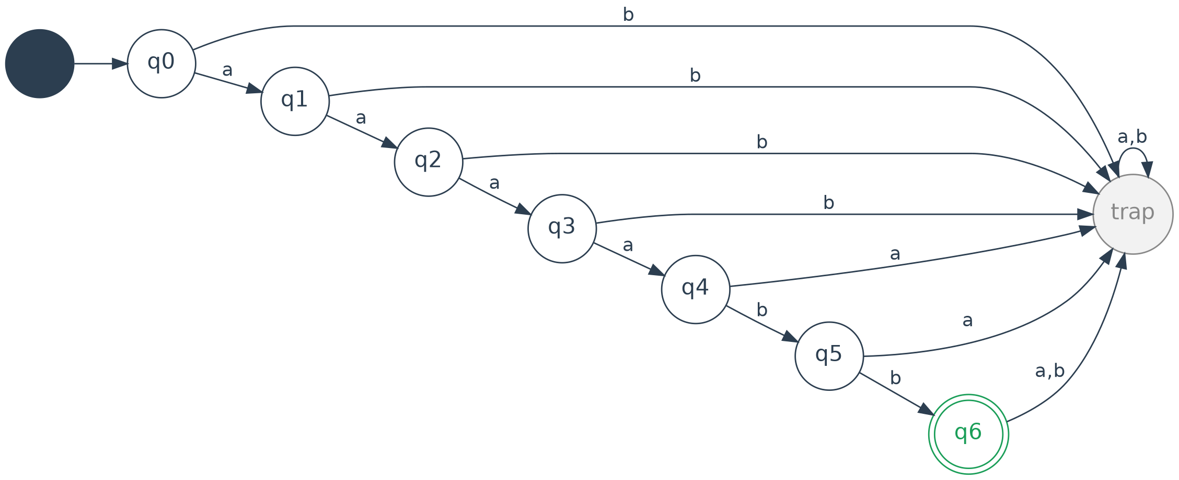
Fig. 2.1 — DFA equivalent to the regex "aaaabb" (trap state absorbs any mismatch)
Each correct symbol advances the automaton one position along the chain; any wrong symbol, or any symbol read after q6 (the accepting state), diverts execution into the non-accepting "trap" state, from which it can never return — correctly rejecting the input.

2.3 Application to Real-World Web Input Validation
- Regular expressions give web frameworks a compact, declarative way to specify valid input formats (fixed tokens, usernames, product codes, OTPs) without writing custom parsing code.
- Email validation: a regex such as ^[\w.+-]+@[\w-]+\.[a-zA-Z]{2,}$ checks structural correctness (local-part, "@", domain, TLD) in a single deterministic pass.
- Password rules: regexes enforce minimum length, and required character classes (uppercase, digit, special symbol) before a form is submitted to the server.
- Because every regex compiles to a finite automaton, matching runs in linear time O(n) in the length of the input, with constant memory (only the current state is stored) — ideal for high-throughput, low-latency form validation and API request filtering.
- This same finite-state matching underlies client-side JavaScript validation, server-side sanitization, and Web Application Firewalls (WAFs) that block malformed or malicious payloads before they reach business logic.

Question 3 — Equivalence of Regular Expressions and Finite Automata
In systems such as intrusion detection, compilers, and real-time monitoring tools, pattern recognition is central. We convert the regular expression a*b* into an equivalent finite automaton and explain why regular expressions and finite automata are equivalent models.

3.1 Regular Expression
r = a*b*
This language contains zero or more a's followed by zero or more b's: L(r) = { aⁱ bʲ | i ≥ 0, j ≥ 0 }, which includes ε, a, aa, b, bb, ab, aab, abb, aabb, etc.

3.2 Step 1 — Build an NFA (with ε-transition) using Thompson-style Construction
a* is built as a self-loop on state q0 (accepting, since a* includes ε). b* is built as a self-loop on state q1 (accepting, since b* includes ε). The two fragments are joined by an ε-transition from q0 to q1, representing concatenation:
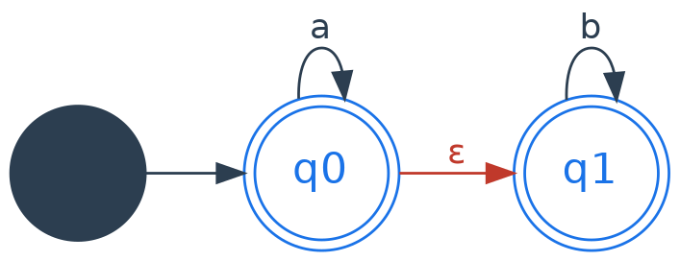
Fig. 3.1 — ε-NFA for a*b* (q0, q1 both accepting)
N = (Q, Σ, δ, q0, F) with Q = {q0, q1}, Σ = {a, b}, F = {q0, q1}, δ(q0,a)={q0}, δ(q0,ε)={q1}, δ(q1,b)={q1}.

3.3 Step 2 — Subset Construction to obtain an equivalent DFA
Taking the ε-closure of q0 gives {q0,q1} as the start set. Applying the subset construction (each DFA state = a set of NFA states reachable together) and adding a trap/dead state for completeness yields:
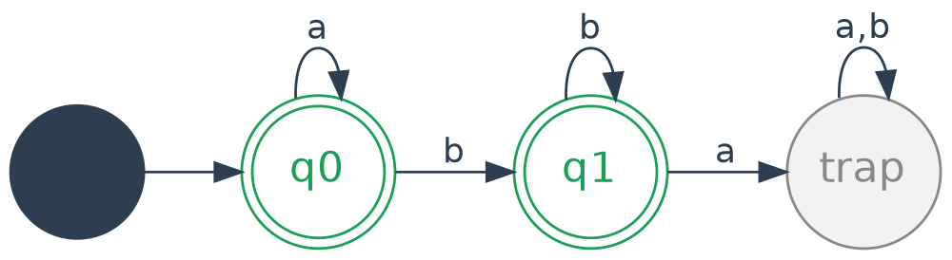
Fig. 3.2 — Equivalent minimized DFA for a*b*
DFA State | Meaning | On a | On b | Accepting?
q0 | {q0,q1} — start | q0 | q1 | Yes
q1 | {q1} | trap | q1 | Yes
trap | dead state | trap | trap | No

3.4 Why Regular Expressions and Finite Automata Are Equivalent
Kleene's Theorem establishes a two-way construction:
- Regex → FA: every regular expression can be converted to an ε-NFA using Thompson's construction (as shown above for a*b*), and every NFA can be converted to a DFA using subset construction.
- FA → Regex: conversely, any DFA/NFA can be converted back into an equivalent regular expression using the state-elimination method (or Arden's theorem), proving both directions of equivalence.
Because the two models describe exactly the same class of languages (the regular languages), a designer can choose whichever representation is most convenient — a regex for concise specification, an automaton for efficient execution — and translate freely between them without any loss of expressive power.

3.5 Application in Real-Time Detection Systems
- Intrusion Detection Systems (IDS) express attack signatures as regular expressions for human readability, then compile them into DFAs for line-rate packet inspection.
- Because DFA execution needs only O(1) work per input symbol and O(n) total time, thousands of signatures can be matched against network traffic in real time without buffering the entire packet.
- Compilers use exactly this equivalence in the lexical analysis phase: token rules are written as regexes and compiled into a single DFA-based scanner for fast, single-pass tokenization.

Question 4 — Pumping Lemma: L = {aⁿbⁿ | n ≥ 0} is Not Regular
In compiler design, not every pattern can be recognized by a finite automaton. We use the Pumping Lemma for regular languages to prove that L = { aⁿ bⁿ | n ≥ 0 } cannot be recognized by any finite automaton.

4.1 Statement of the Pumping Lemma
If L is regular, there exists a pumping length p ≥ 1 such that every string w ∈ L with |w| ≥ p can be split into three parts w = xyz satisfying:
- |xy| ≤ p
- |y| > 0
- xyⁱz ∈ L for every i ≥ 0
If we can show that no such decomposition exists for some string in L, then L cannot be regular (proof by contradiction).

4.2 Proof by Contradiction
Assume, for contradiction, that L = {aⁿbⁿ | n ≥ 0} is regular. Then a pumping length p must exist. Choose the string w = a^p b^p ∈ L, which has length 2p ≥ p.
By the lemma, w = xyz with |xy| ≤ p and |y| > 0. Since |xy| ≤ p, and the first p symbols of w are all a's, both x and y must consist entirely of a's. So y = a^k for some k with 1 ≤ k ≤ p.
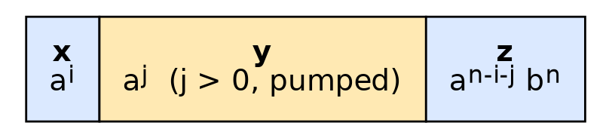
Fig. 4.1 — Decomposition of w = aᵖbᵖ into x, y, z (y lies entirely inside the a-block)
Now pump y down, taking i = 0: xy⁰z = xz = a^(p-k) b^p. Since k > 0, the number of a's (p−k) is strictly less than the number of b's (p), so xz ∉ L.
This contradicts condition 3 of the pumping lemma, which requires xyⁱz ∈ L for every i ≥ 0, including i = 0. Therefore our assumption is false, and L = {aⁿbⁿ | n ≥ 0} is not regular. ∎

4.3 Implications for Modern Compiler Design
- Finite automata (and hence regular expressions) cannot count or match nested/balanced structures — this is exactly why matching parentheses, braces {}, and nested function calls cannot be done with a lexer alone.
- Compilers therefore split language recognition into two stages: a DFA-based lexer handles the regular, token-level structure (identifiers, keywords, operators), while a push-down automaton (context-free grammar / parser using a stack) handles the nested, non-regular structure such as balanced brackets and nested expressions.
- Understanding this limit prevents engineers from wasting effort trying to solve inherently non-regular problems (e.g., balanced-tag validation in HTML/XML) using regex alone — a common real-world pitfall.

Question 5 — Closure Properties for Combining Detection Rules
Modern systems such as intrusion detection, spam filtering, and input validation often need to combine multiple pattern-matching rules. Closure properties of regular languages guarantee that the combined rule is still implementable as a single finite automaton.

5.1 Key Closure Properties of Regular Languages
Operation | Definition | Result Regular?
Union (L1 ∪ L2) | Strings accepted by rule 1 OR rule 2 | Yes
Intersection (L1 ∩ L2) | Strings accepted by rule 1 AND rule 2 | Yes
Concatenation (L1 · L2) | A match of rule 1 immediately followed by a match of rule 2 | Yes
Kleene Star (L1*) | Zero or more repetitions of rule 1 | Yes
Complement (L1ᶜ) | Everything rule 1 does NOT match | Yes

5.2 Why the Combined Language Stays Regular
Each operation has a constructive automaton-level proof, which is what guarantees the result can still be implemented in hardware/software as a finite automaton:
- Union: build the product automaton of M1 and M2 — a new state is the pair (state of M1, state of M2), accepting if either component accepts.
- Intersection: same product construction, but accepting only if both components accept simultaneously.
- Concatenation: connect the accepting states of M1 to the start state of M2 with ε-transitions (NFA), then apply subset construction to get a DFA.
- Complement: for a DFA, simply swap accepting and non-accepting states (requires the DFA to be complete, i.e., have a trap state).
In every case, the construction produces a new, well-defined finite automaton — proving the result is regular, not merely asserting it.
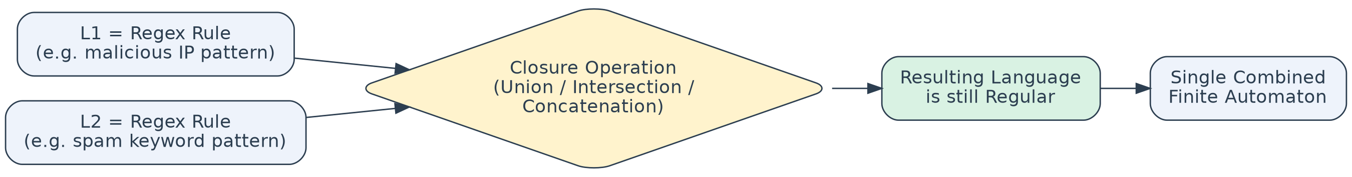
Fig. 5.1 — Combining two rule-automata via a closure operation yields one regular, executable automaton

5.3 Application to Real-World Detection Systems
- Intrusion Detection: a rule for 'malicious IP pattern' (L1) and a rule for 'suspicious port sequence' (L2) can be combined with intersection to flag traffic matching both conditions simultaneously, using one combined automaton instead of two separate passes over the data.
- Spam Filtering: keyword-based rules can be combined using union — a single email is flagged as spam if it matches ANY of several suspicious phrase patterns — and the whole filter still runs as one DFA over the email text in a single linear pass.
- Input Validation: complement is used to build a blacklist filter (reject everything except explicitly well-formed input), while concatenation chains together format rules, e.g. (username-pattern) · '@' · (domain-pattern) for email fields.
- Because closure guarantees the combined rule set is still regular, engineers can merge arbitrarily many detection rules and still compile them down to a single, efficient DFA that processes each input symbol in O(1) time — essential for line-rate network monitoring and real-time filtering.

RUBRICS FOR CALCULATION

Criteria | Weightage | Level 4 –  Exemplary (5 Marks) | Level 3 –  Proficient (4 Marks) | Level 2 –  Developing (2–  3 Marks) | Level 1 – Beginning  (0–1 Mark)
Conceptual Understandin g | 30 | Demonstrates clear and complete understanding  of the concept | Good understandi ng with minor gaps | Basic understanding with some misconception  s | Poor or incorrect understandi ng
Accuracy of Answer | 25 | Completely correct answer with no errors | Mostly correct with minor errors | Partially correct with noticeable  errors | Incorrect or irrelevant answer
Application of Knowledge | 20 | Correctly applies concepts to solve the question/probl  em | Applies concepts with minor mistakes | Limited or partially correct application | No or incorrect application
Completenes s of Response | 15 | Covers all required parts of the question | Covers most parts with minor  omissions | Covers only some parts | Incomplete or missing response
Clarity & Presentation | 10 | Clear, concise, and well-  organized answer | Understanda ble with minor issues | Somewhat unclear or  poorly structured | Difficult to understand

